1
33
On-Device AI 실습
Quantization for CNN
Dongkun Shin
Intelligent Embedded Systems Lab.
Sungkyunkwan University
Intelligent Embedded Systems Lab. @ SKKU
Overview
2
33
1. Uniform Quantization
– Linear Quantization
– Per-tensor / Per-channel Quantization
– Quantized inference
2. Non-uniform Quantization
– K-Means Quantization, Quantization-aware Training
3. Quantization with PyTorch API
– Post-Training Quantization, Quantization Aware Training
Intelligent Embedded Systems Lab. @ SKKU
Linear Quantization ³33
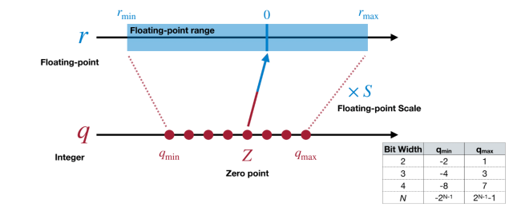
Intelligent Embedded Systems Lab. @ SKKU
Linear Quantization ⁴33
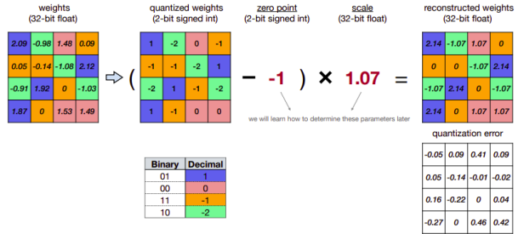
Intelligent Embedded Systems Lab. @ SKKU
[실습1] Linear Quantization 함수 구현 ⁵ 33
Given the zero point and scale, how is a tensor quantized?
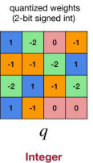
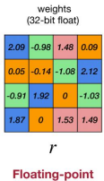
= =
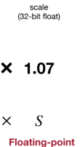
÷ ÷
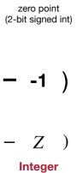
+ +
Intelligent Embedded Systems Lab. @ SKKU
[실습1] Linear Quantization 함수 구현 ⁶ 33
�� = ��/�� + ��
= =
÷ ÷
+ +
Intelligent Embedded Systems Lab. @ SKKU
[실습1] Linear Quantization 함수 구현 ⁷ 33
�� = ������(����������(��/��)) + ��
= =
÷
÷
+
+
Intelligent Embedded Systems Lab. @ SKKU
[실습1] Linear Quantization 함수 구현 ⁸33
Intelligent Embedded Systems Lab. @ SKKU
Linear Quantization - Scale ⁹33
Intelligent Embedded Systems Lab. @ SKKU
Linear Quantization - Scale ¹⁰ 33
Min & Max value of fp tensor
Intelligent Embedded Systems Lab. @ SKKU
Linear Quantization – Zero Point ¹¹33
Intelligent Embedded Systems Lab. @ SKKU
Linear Quantization – Zero Point ¹²33
Intelligent Embedded Systems Lab. @ SKKU
[실습2] Scale and Zero Point 계산 ¹³33
Intelligent Embedded Systems Lab. @ SKKU
[실습2] Scale and Zero Point 계산 ¹⁴33
Intelligent Embedded Systems Lab. @ SKKU
Per-Channel Linear Quantization ¹⁵ 33
• Different scaling factors S and zero points Z for different output channels will perform better
Intelligent Embedded Systems Lab. @ SKKU
Quantized Matrix Multiplication ¹⁶33
Intelligent Embedded Systems Lab. @ SKKU
Quantized Inference ¹⁷33
Intelligent Embedded Systems Lab. @ SKKU
Quantized Inference ¹⁸33
Intelligent Embedded Systems Lab. @ SKKU
[실습3] Quantized Fully-Connected Layer ¹⁹33
Intelligent Embedded Systems Lab. @ SKKU
[실습3] Quantized Convolution Layer ²⁰33
Intelligent Embedded Systems Lab. @ SKKU
[실습3] Quantized Layer ²¹33
Intelligent Embedded Systems Lab. @ SKKU
Model Fusion ²² 33
• We can fuse a BatchNorm layer into its previous convolutional layer • Fusing model can reduce the extra multiplication during inference
Intelligent Embedded Systems Lab. @ SKKU
Inference with quantized model ²³33
Intelligent Embedded Systems Lab. @ SKKU
K-Means Clustering
24
33
• Popular unsupervised learning algorithm to group data into �� clusters • Select �� initial centroids and assign each data point into nearest centroids
• Update centroids by calculating the mean of the assigned points
Intelligent Embedded Systems Lab. @ SKKU
K-Means-based Weight Quantization ²⁵ 33
Cluster
Intelligent Embedded Systems Lab. @ SKKU
K-Means-based Weight Quantization ²⁶33
Intelligent Embedded Systems Lab. @ SKKU
[실습4] K-Means Quantization 함수 구현
27
33
• Get number of clusters (2��) based on the quantization precision • Decode the codebook into k-means quantized tensor for
inference
labels
Intelligent Embedded Systems Lab. @ SKKU
[실습4] K-Means Quantization 함수 구현 ²⁸33
Intelligent Embedded Systems Lab. @ SKKU
QAT with K-means quantization ²⁹33
Intelligent Embedded Systems Lab. @ SKKU
[실습5] Fine-tuning K-means quantization ³⁰ 33
For simplicity, directly
update the centroids
according to the latest
weights
Intelligent Embedded Systems Lab. @ SKKU
[실습5] Fine-tuning K-means quantization ³¹33
Intelligent Embedded Systems Lab. @ SKKU
Quantization with PyTorch API ³² 33
Machine Learning Libraries
Intelligent Embedded Systems Lab. @ SKKU
Quantization with PyTorch API ³³33
Intelligent Embedded Systems Lab. @ SKKU

